# Fiori Launchpad Content Manager Tool:

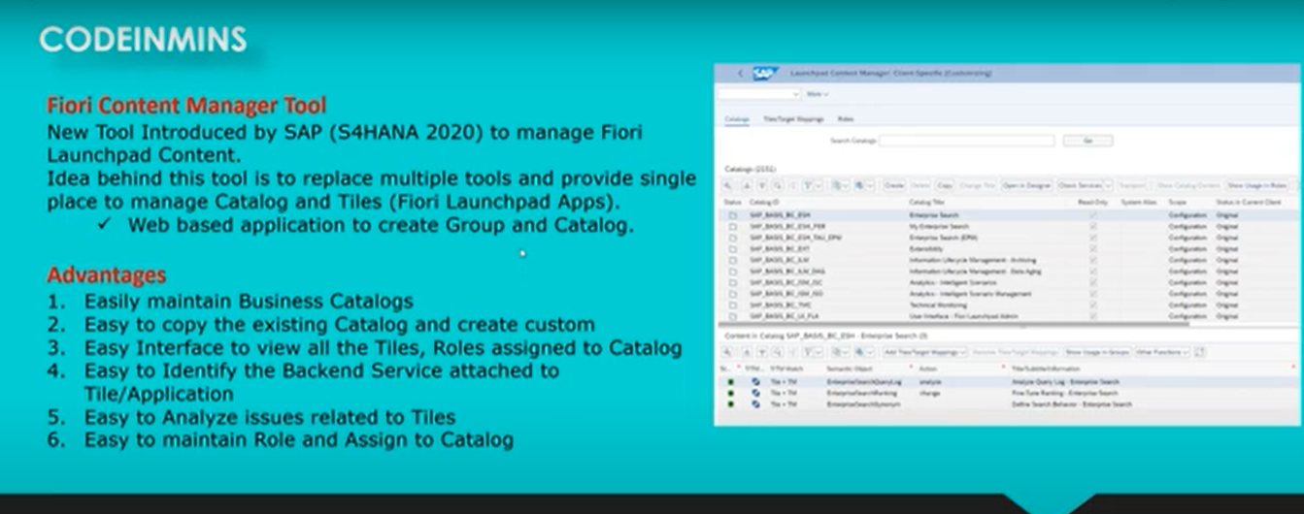

Content Manager Tool : is the collection multiple tools

-- used to configure the fiori launch pad.

-- create the catalog and assign the roles and tiles

-- before S4 HANA 2020, we have used the different transactions / different tools available to configure the Fiori launchpad.

-- in the system all of the fiori launch pad content, SAP come up with the these tool and placed everything in one place and everything very connected and you can switch easily from one object to other object

Ex: you can search the catalogue / you can switch from catalogue to the tiles/you can switch to the roles/ you can switch to the assigned roles to the PFCG transactions/ you can switch to maintain the service transactions.

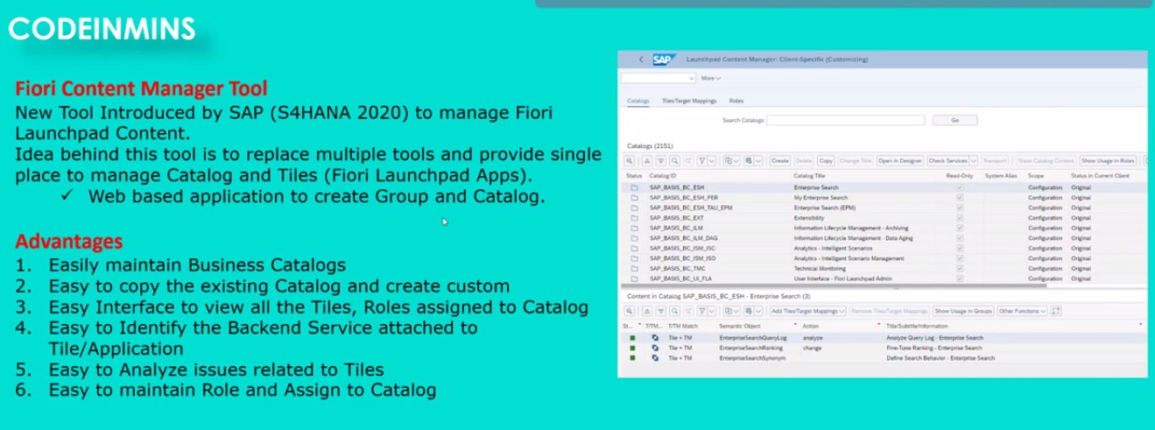

Content manager tool : introduced from S4HANA-2020

use: to create the catalog and to create the business catalogue and this tool replaced with create catalogue and create group with web based applications.

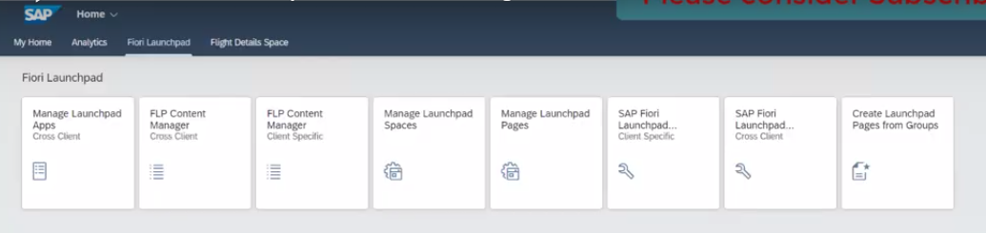

below the tile used for FLP content Manager tool

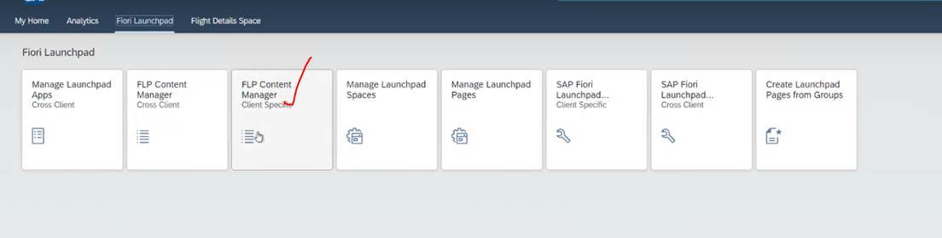

Let click on the tool :Content Manager Tool now our tool is open with SAP screens at browser level.

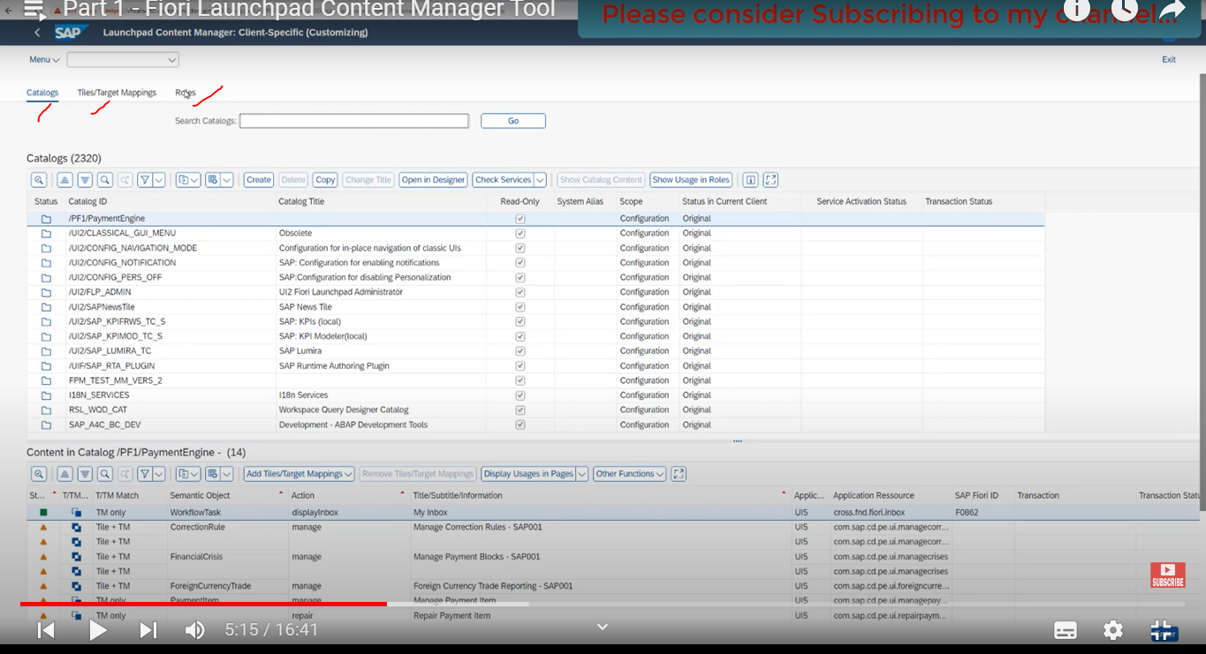

in some of the previous videos which we are going through on the fiori- we have created the tile so applying the tile to the fiori launchpad or adding the tile to the fiori launchpad, we have also created the catalogue.

Lets try to search the catalogue to these locations, we have not used these tool while we have created the catalogue.

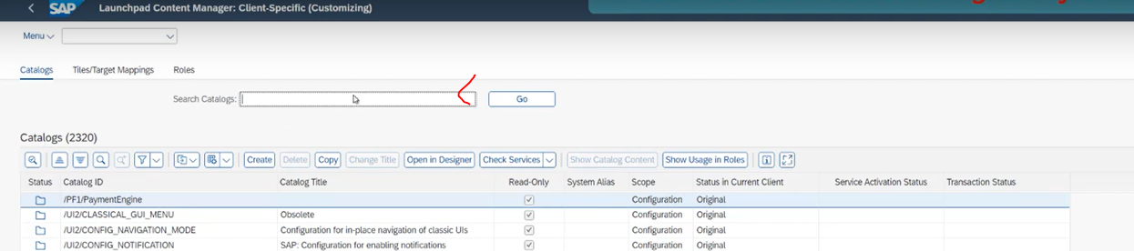

5:00

our catalogue name is :ZCODEINMINS_C

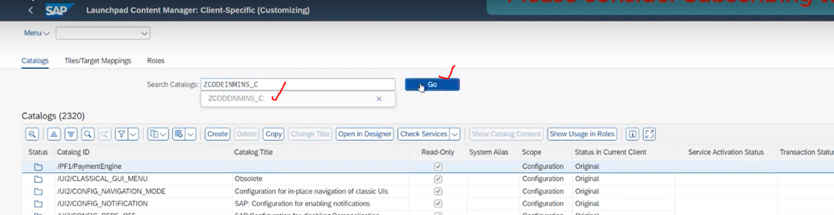

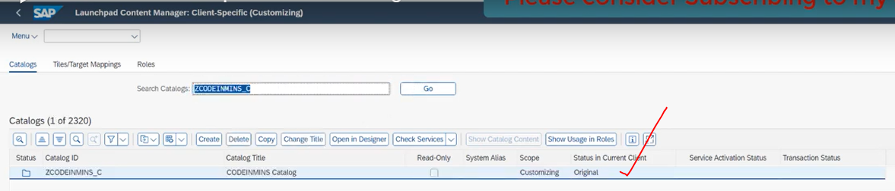

our catalogue is now available here, when you click on catalogue here--> you can able to see the what are the tiles available here..

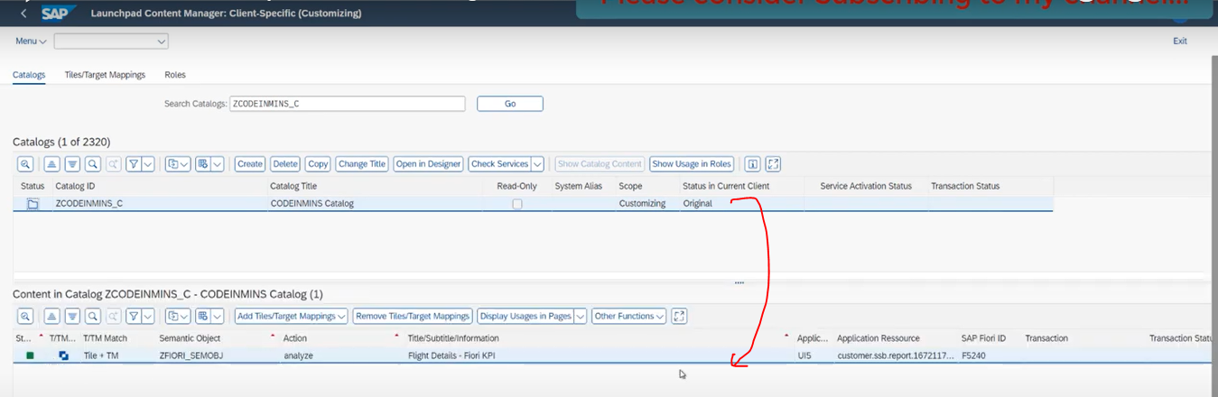

in tile report, you can able to see the target mapping available here

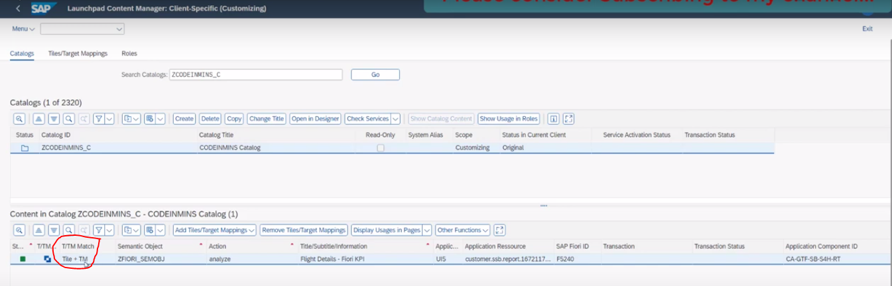

able to see the semantic object :ZFIORI_SEMOBJ

able to see the action :Analyze

Application Type : either UI5 or GUI appication.

SAP Fiori Id: is unique number: F5240

in drill down report, you can able to see also so many buttons and so many options are available

-- already if you have the catalogue and if you have the tile --> then click on Add tiles/Target Mapping button.

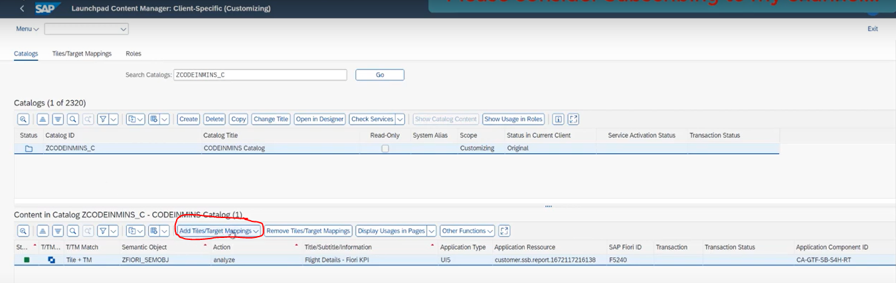

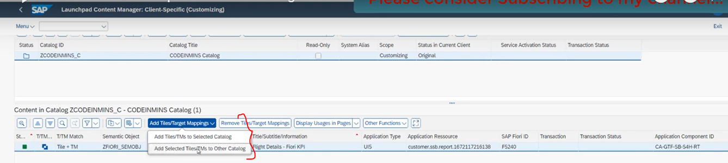

Display usages in Pages:

-- where which places the tile has been used, click on display usage in pages.

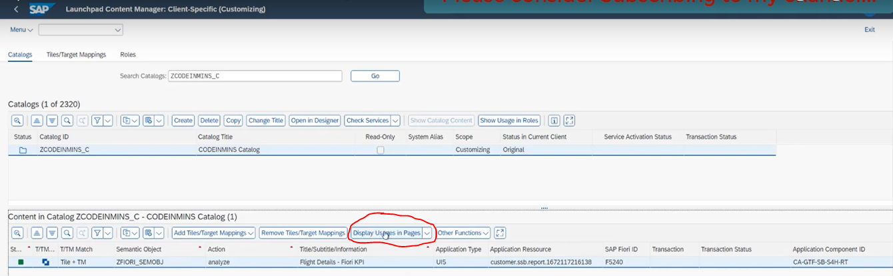

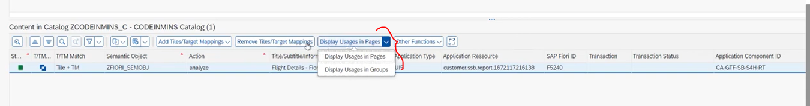

-- Other Functions button

you show the status details selected KPI tile.

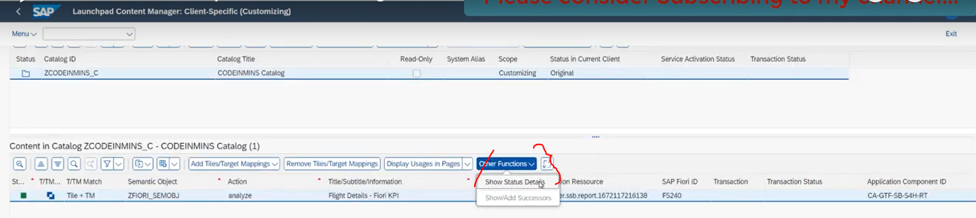

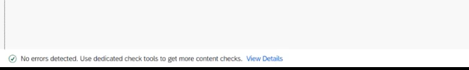

-- Open in Designer View button

When you click on these buttons - Open web applications which we have used the before S4 Hana-2020

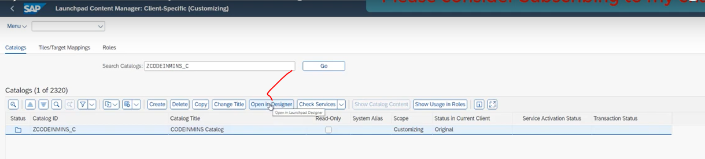

-- Check services button

what are the services attached for this catalogue.

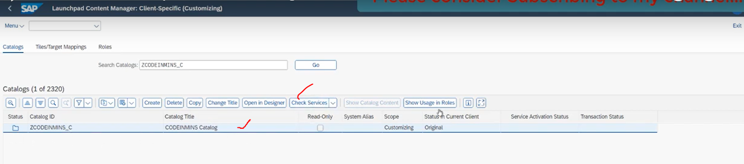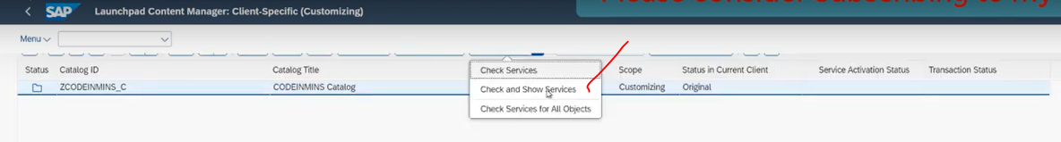

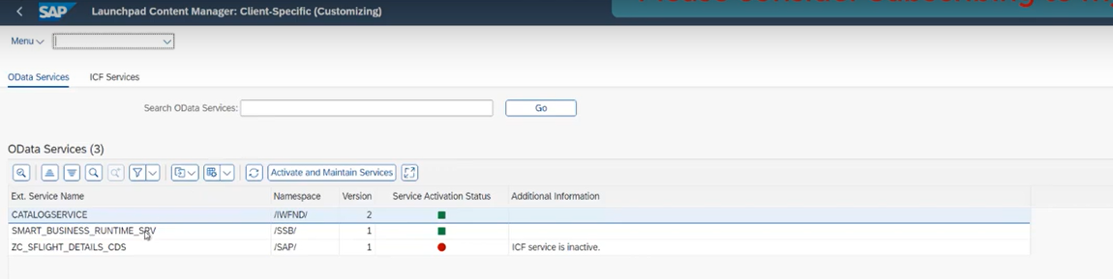

above services are available for these catalogue.

ICF Nodes as well

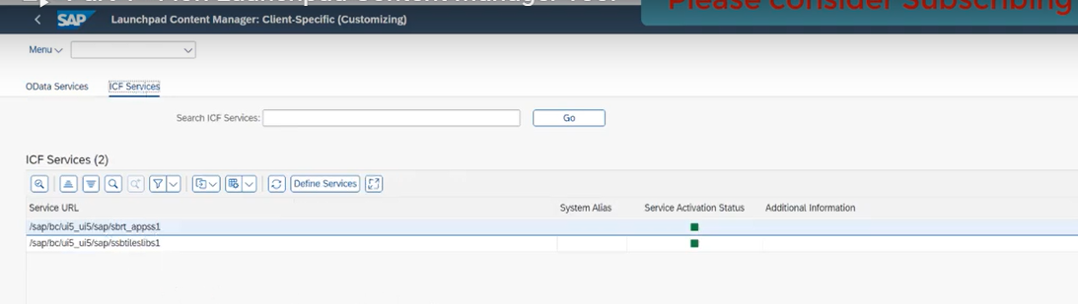

-- Show usage Roles

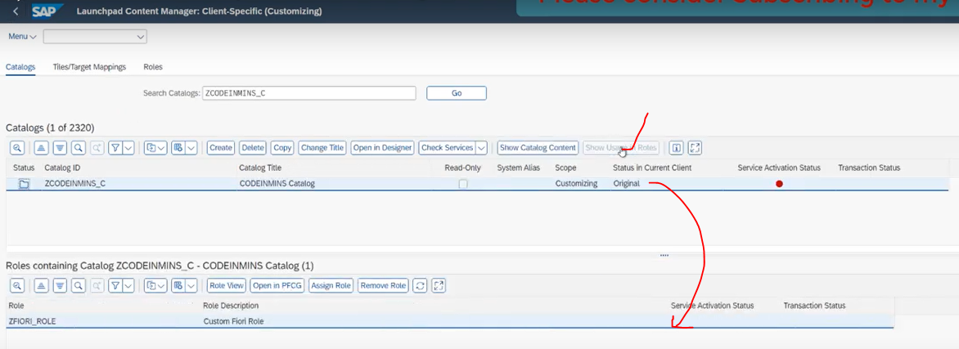

in this catalogue what are the roles attached for specific catalogue.

Lets move to the Tiles and Target mappings:

-- TIles and Target Mappings

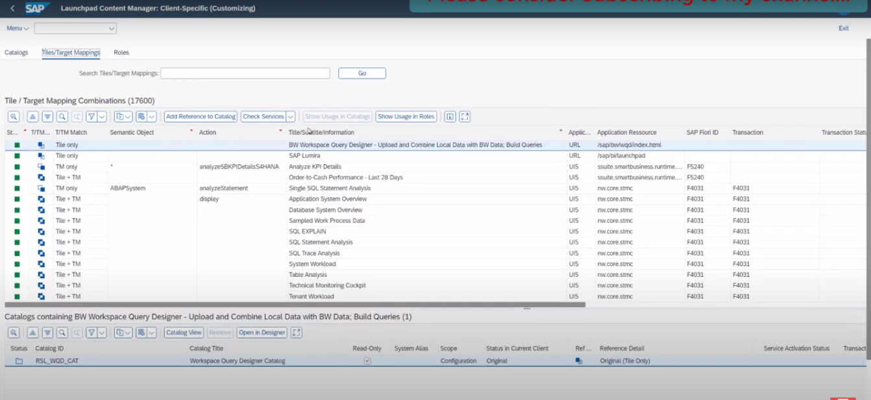

these tab will show you each and every tile, which is currently available in the system

all of the tiles showing here..

from here only you can add the reference to the catalogue...

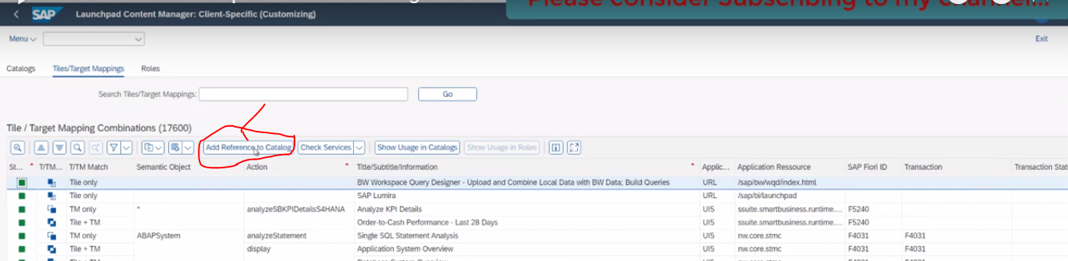

Add reference to the catalog: suppose if you created the tile and then assigned to the catalogue you can do with Add reference to the catalogues.

check services: what are the services available for specific tile.

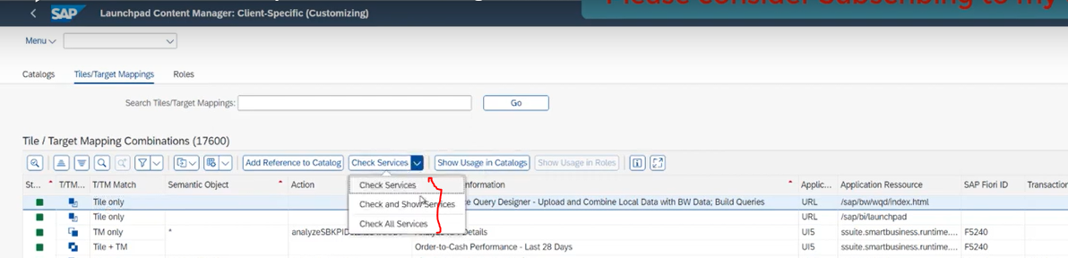

Show usage in catalogues: basically it is showing in which catalogue tile is assigned to the these catalogues.

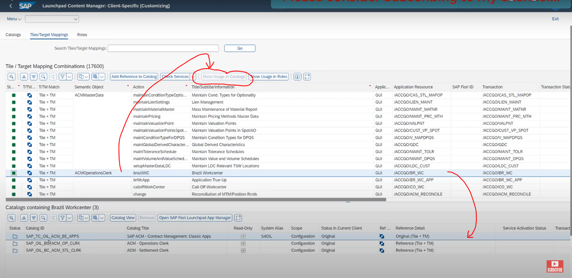

-- Roles Tab:

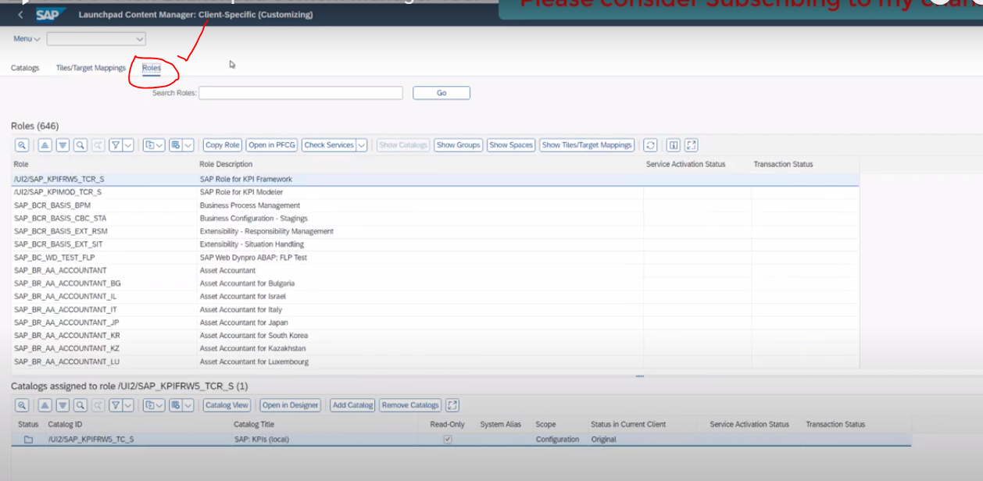

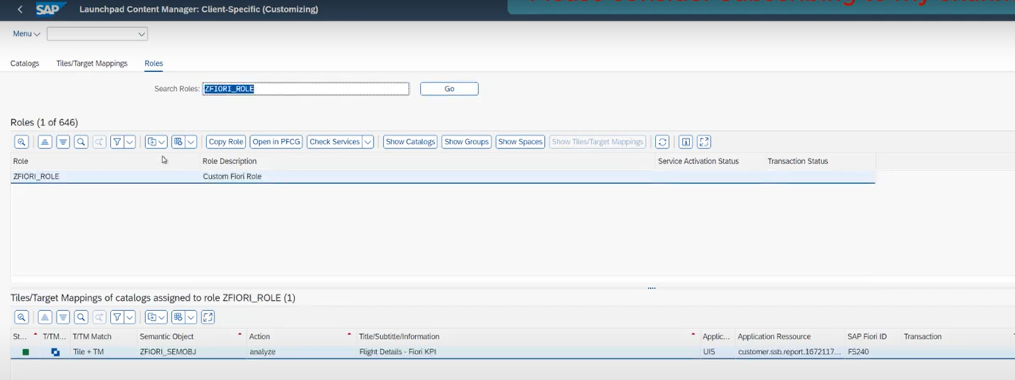

check the services to attached the role

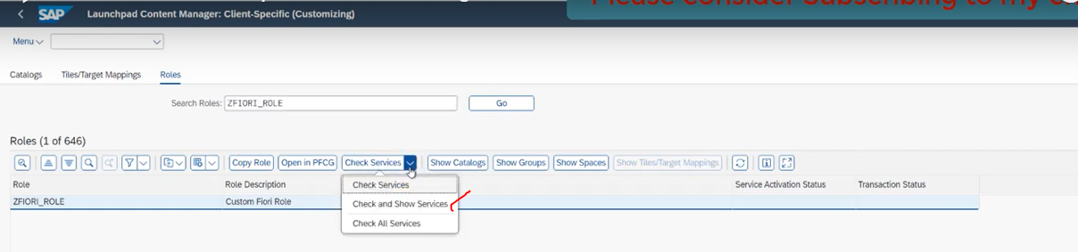

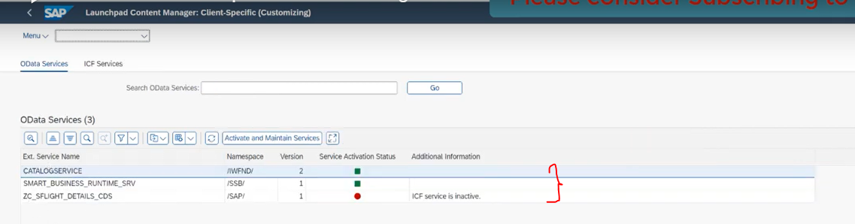

Lets see the catalogues:

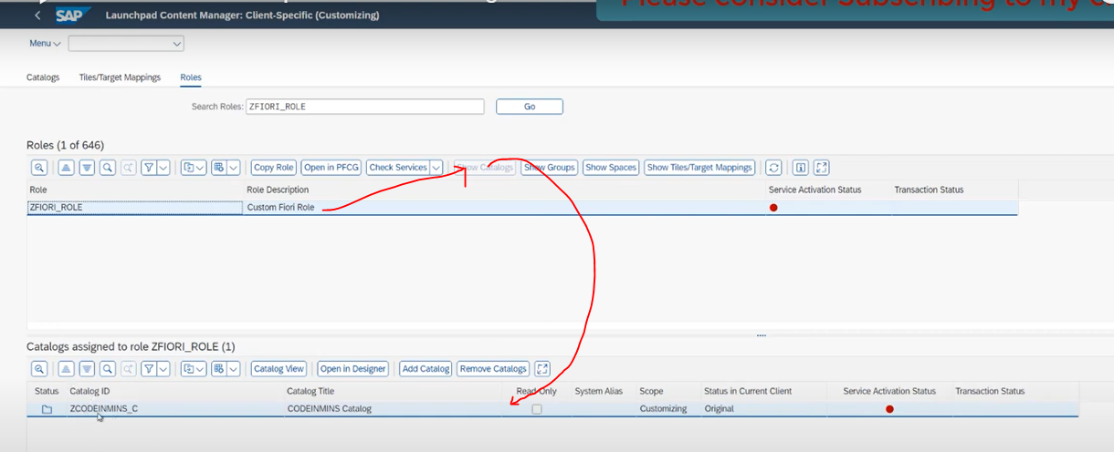

Show Spaces:

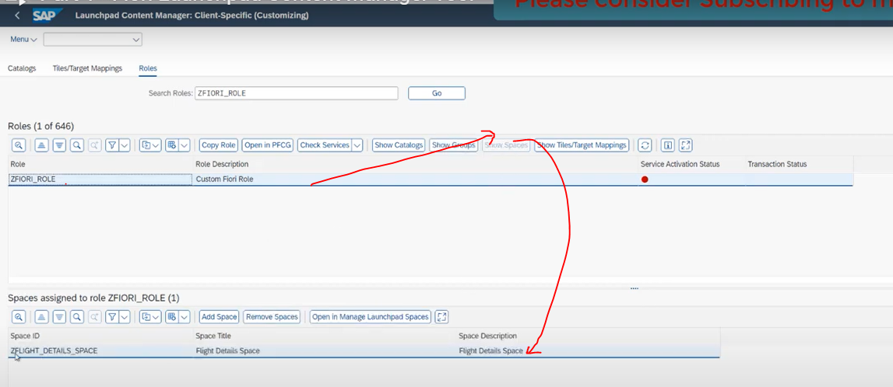

Tiles/Target Mapping:

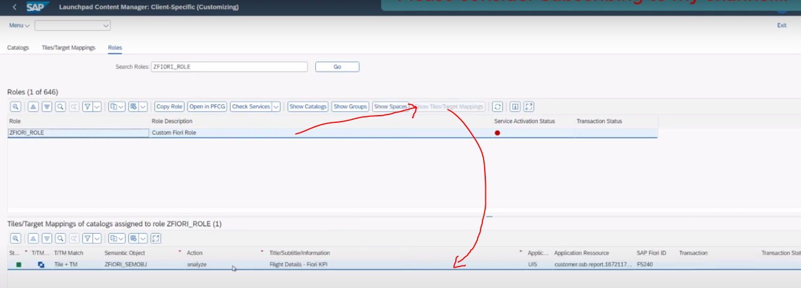

# using Fiori Content Manager Tool to create the catalogue and assign the roles and tiles and pages.

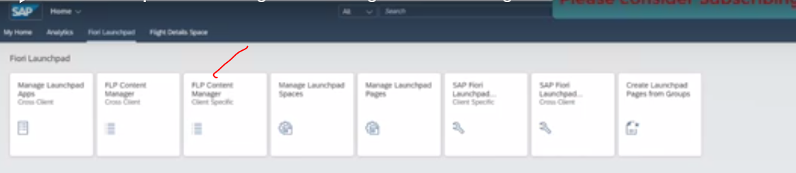

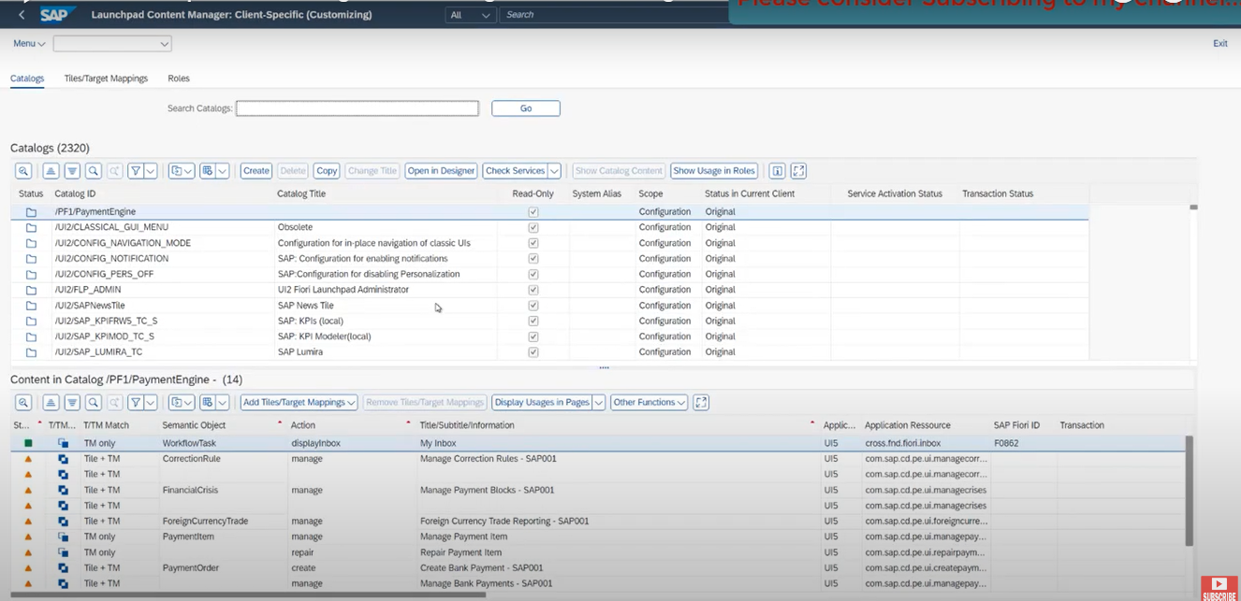

Now we are in catalogue tab:

click on create button: to create the new catalogue.

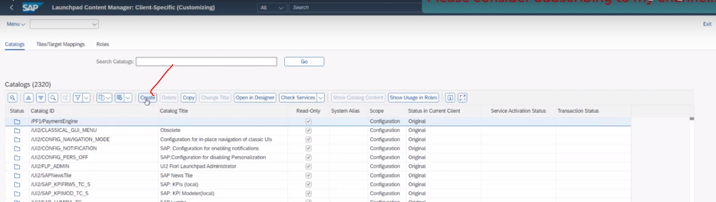

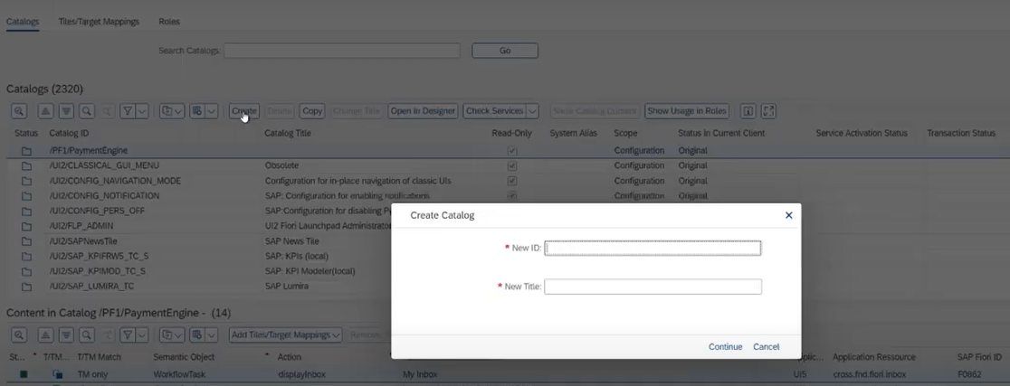

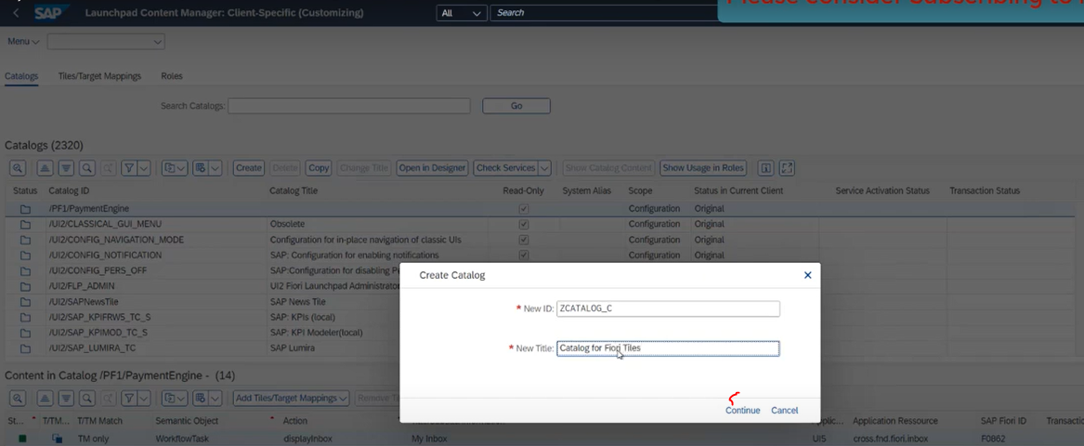

Save it in customizing request.

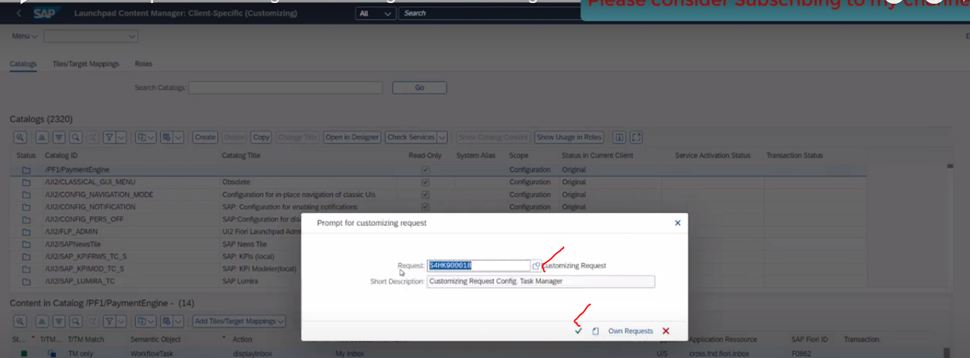

ZCATALOG_C --> Created(New Catalog)

for new catalog we don't have anything available in drop down list

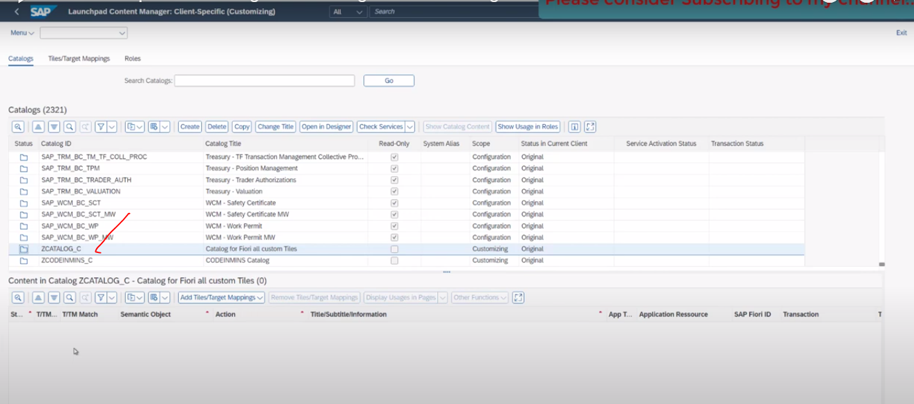

Now add the exist tile to new catalog.

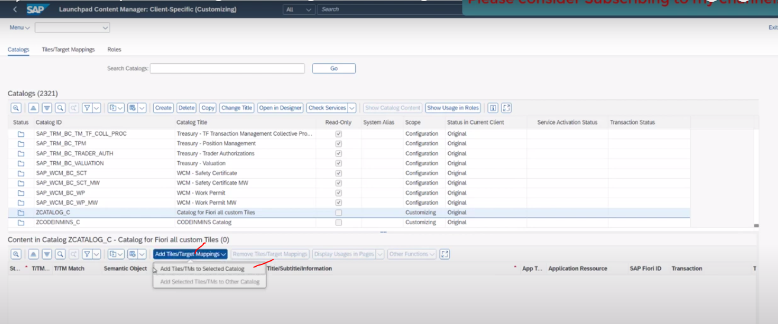

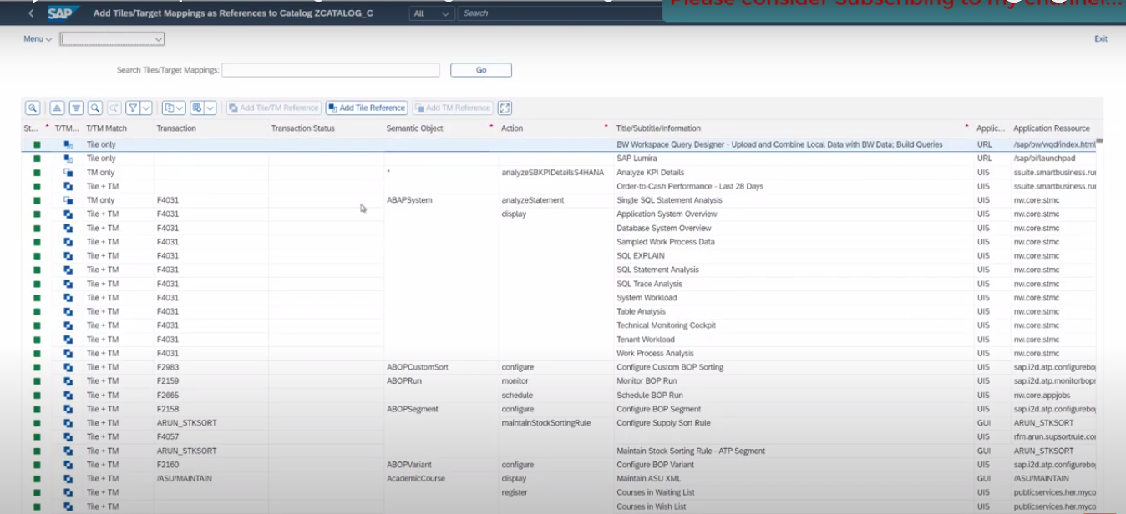

Search with the exist tile.

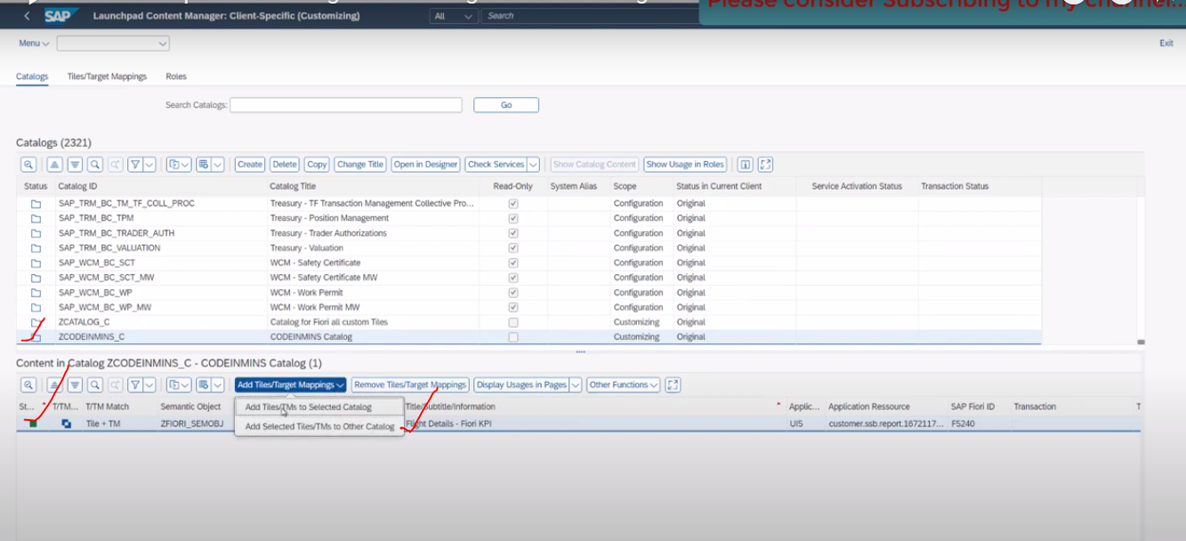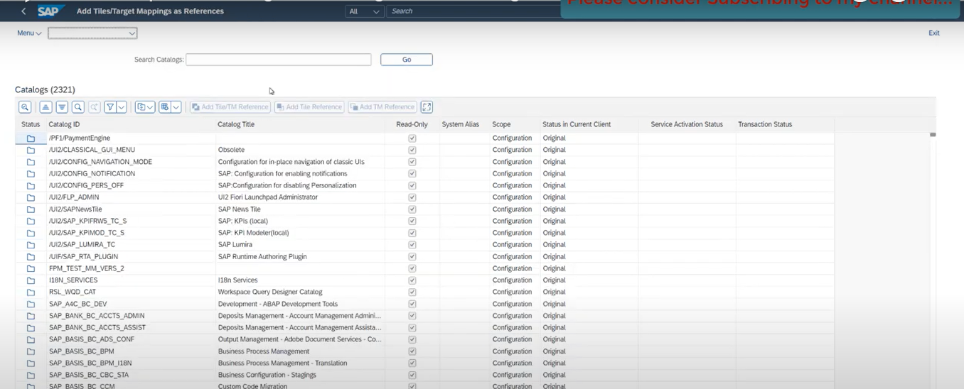

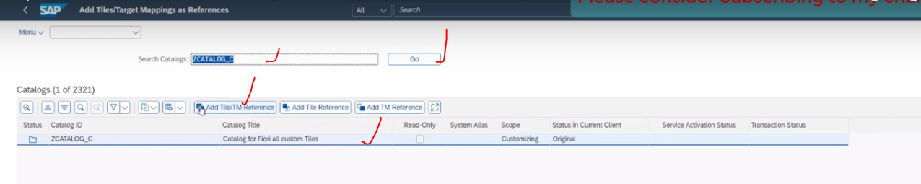

Now our catalog added to exist tiles

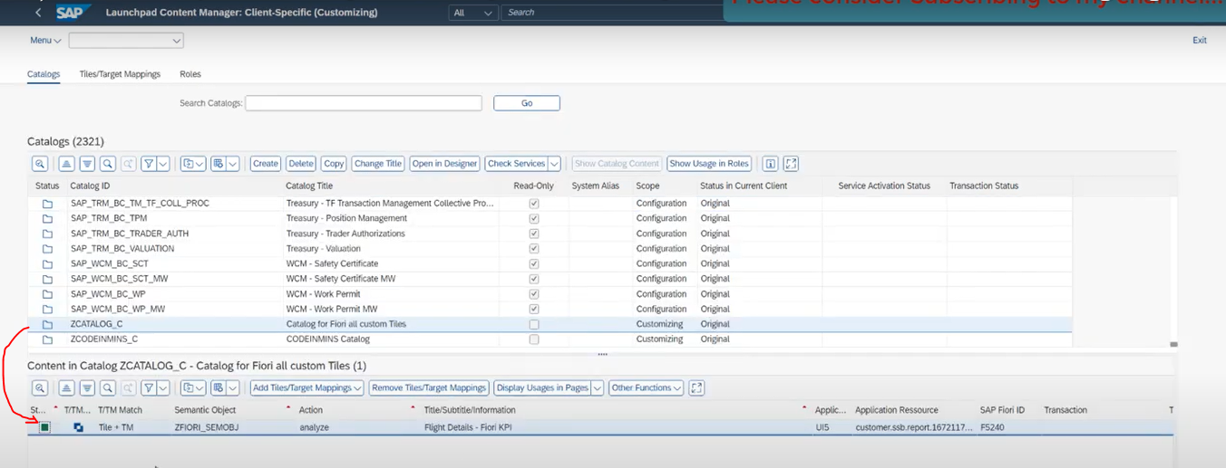

Now it is assigned to the tile

Catalog -->TIle(Semantic Object)

Now we need to assign the role:

Role: ZFIORI_ROLE

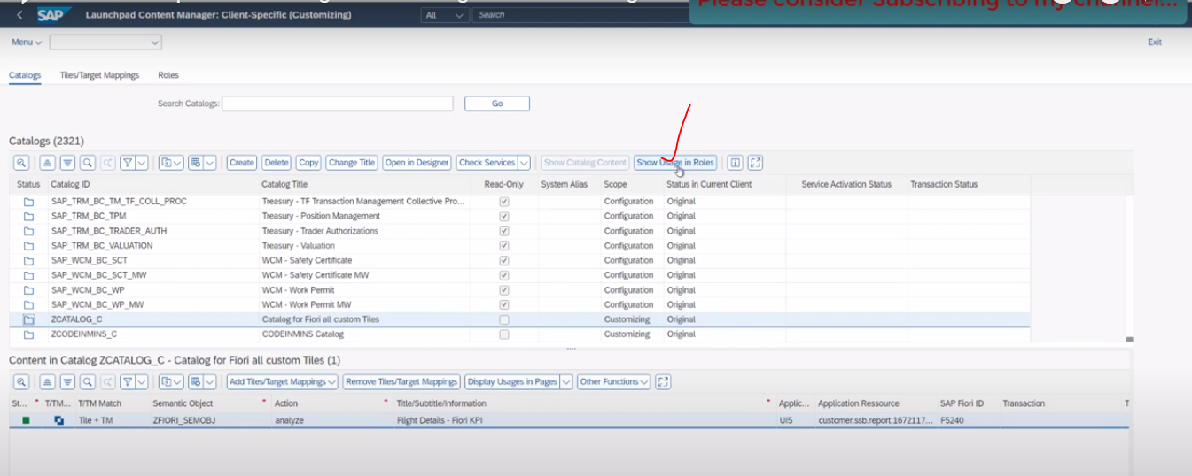

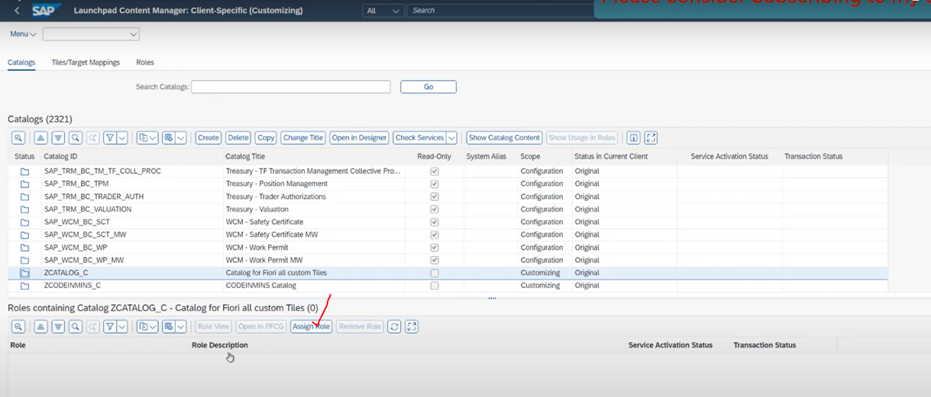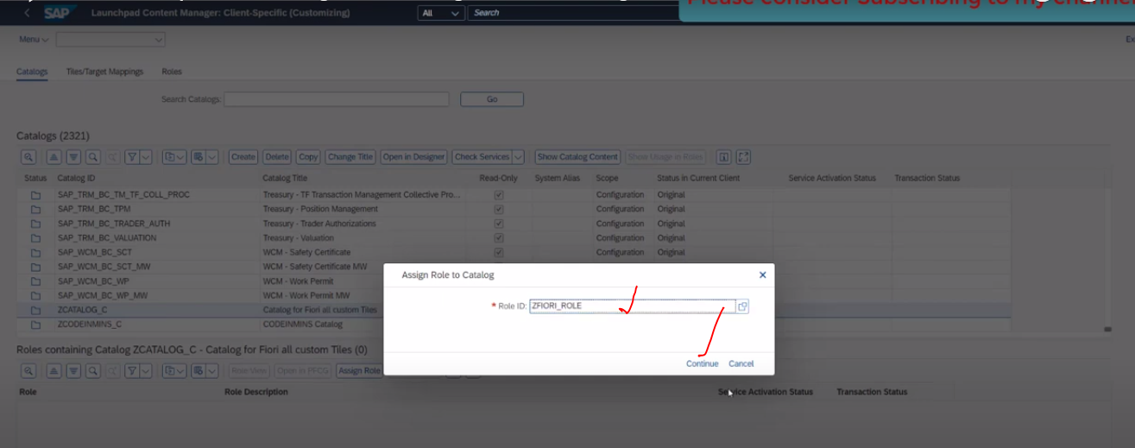

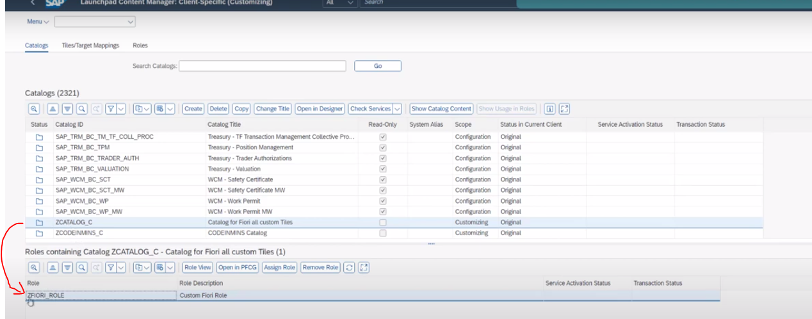

role assigned to the catalog.

Now assign catalog to the space.

check by the role.

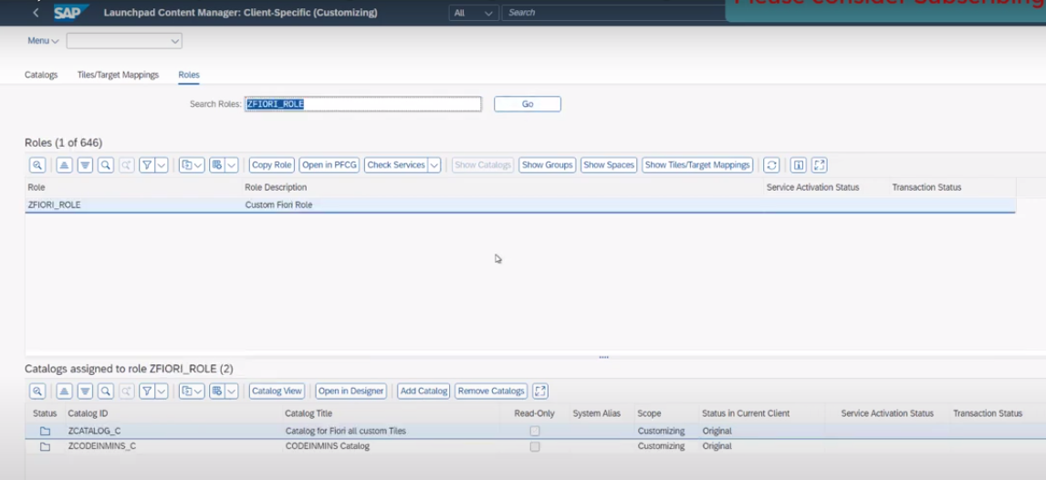

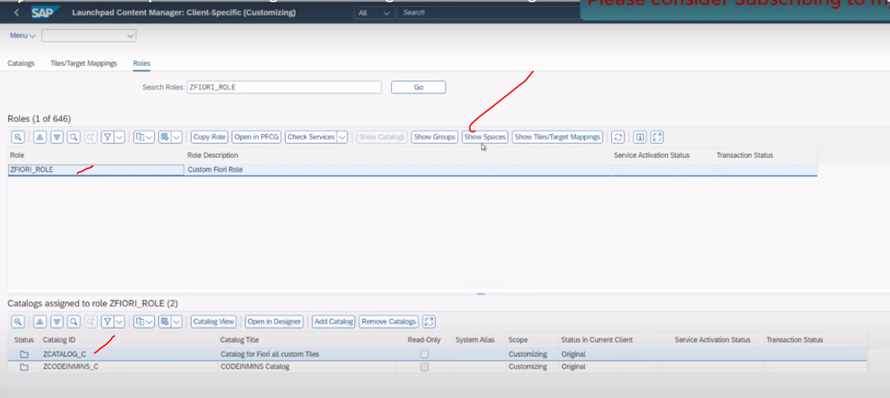

this role already assigned to the space.

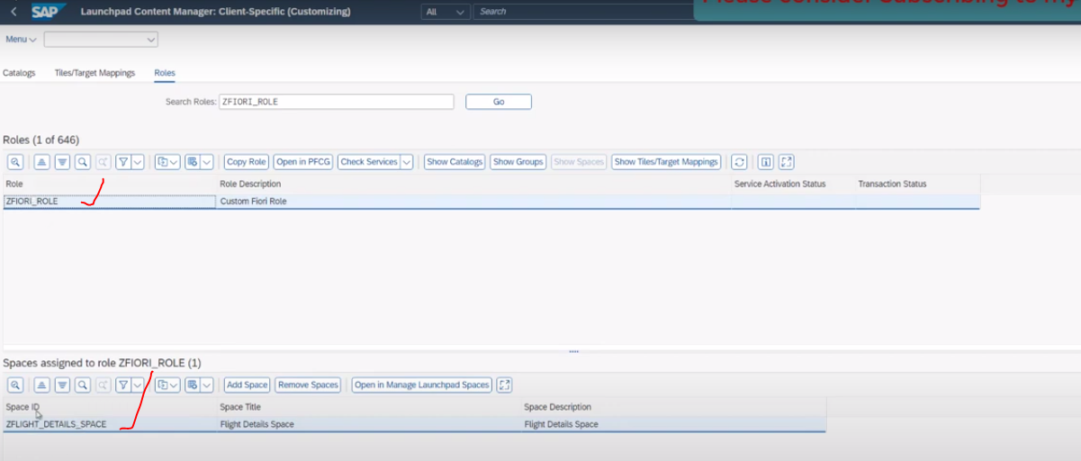

we also want to assign our catalog/tile to the space

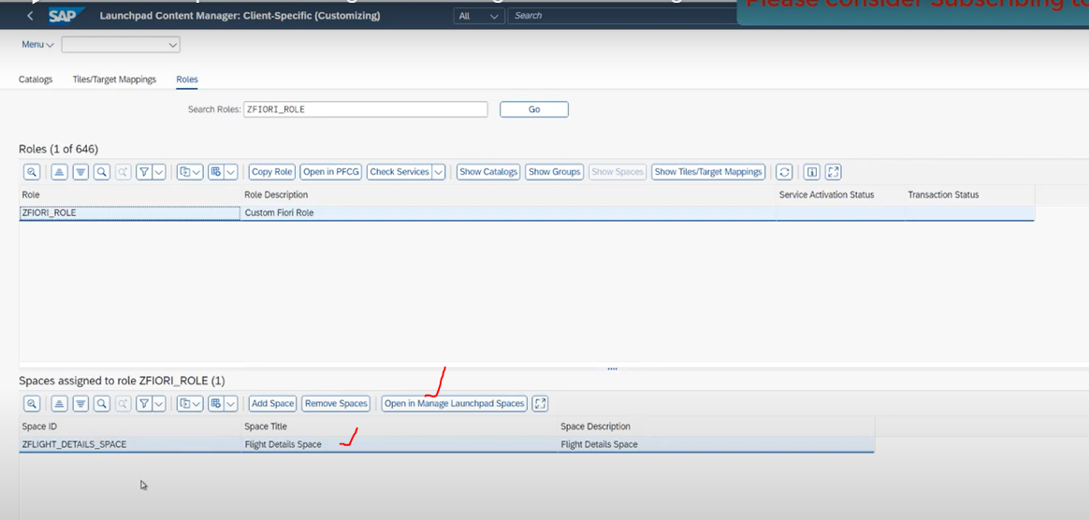

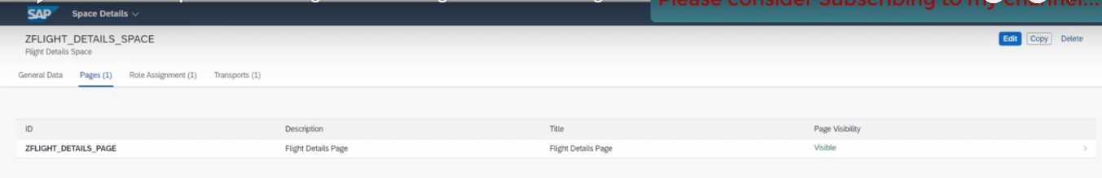

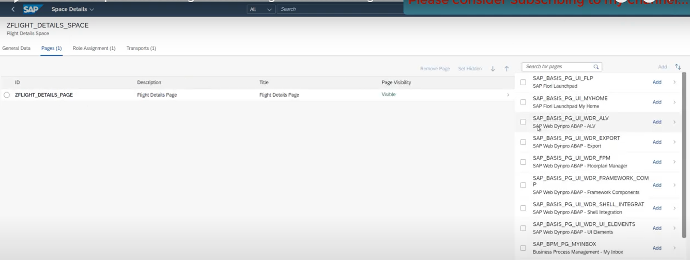

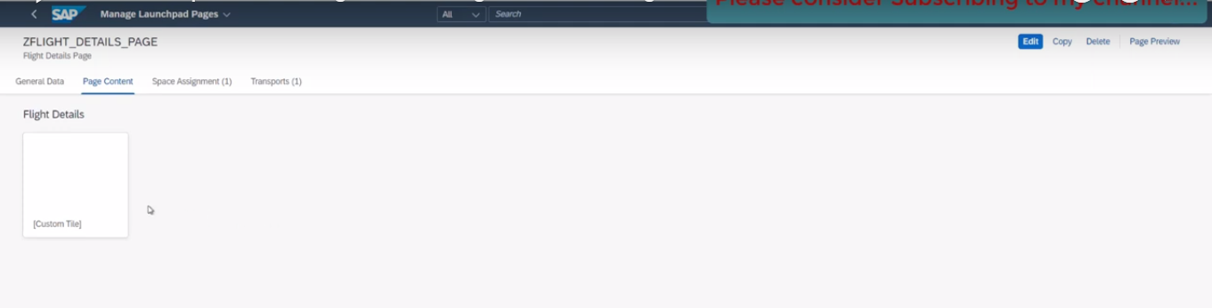

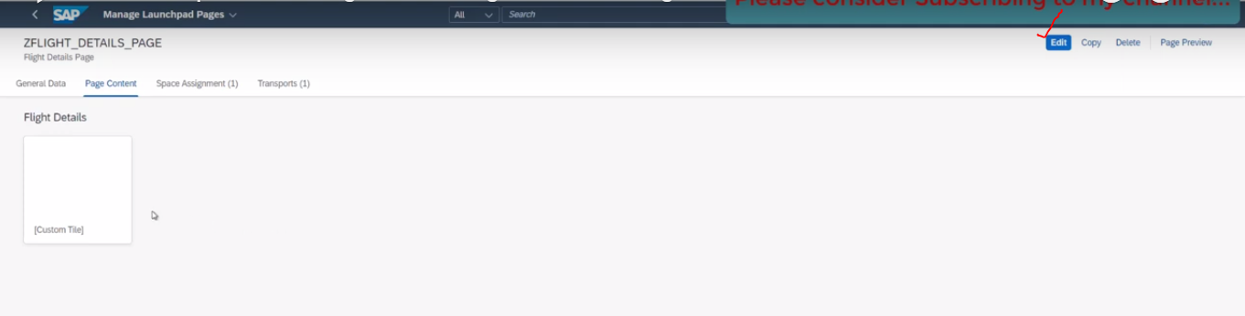

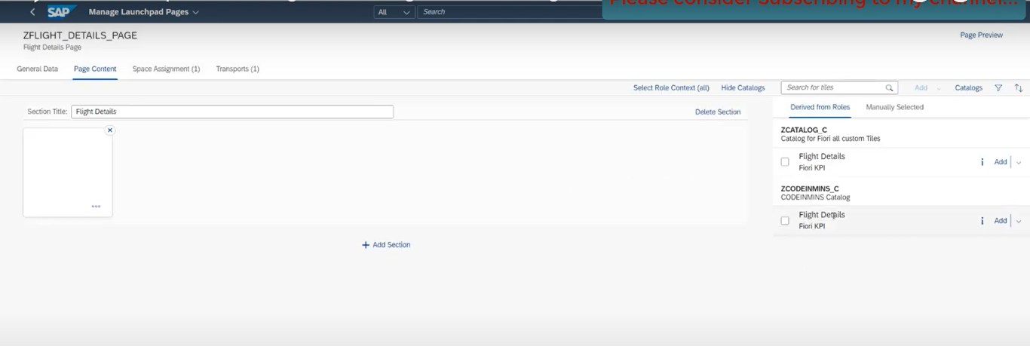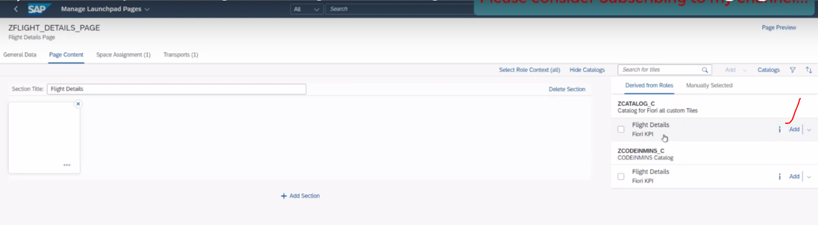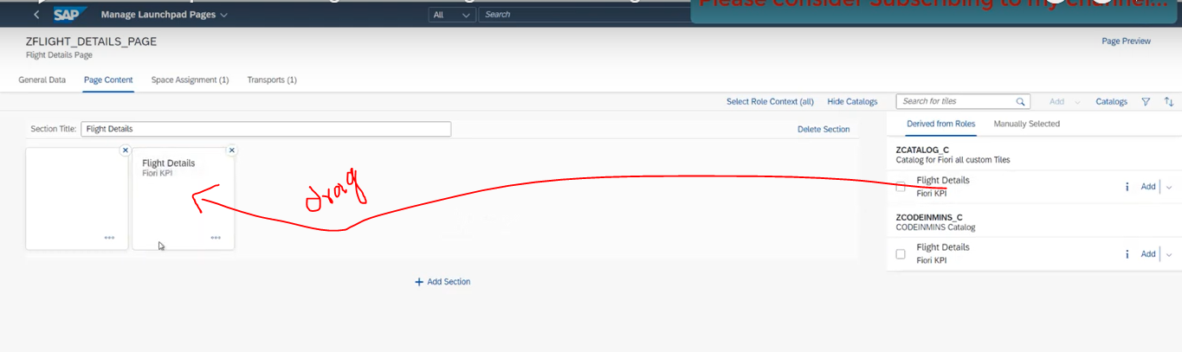

click on SAVE button

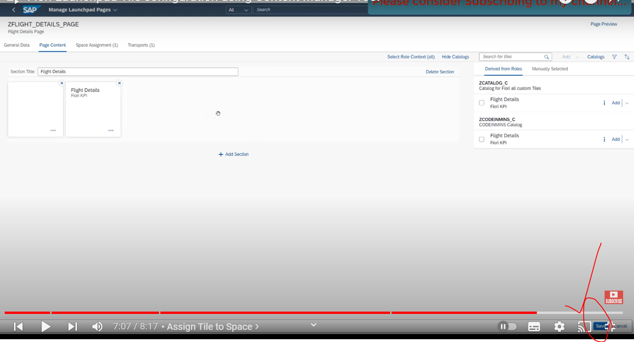

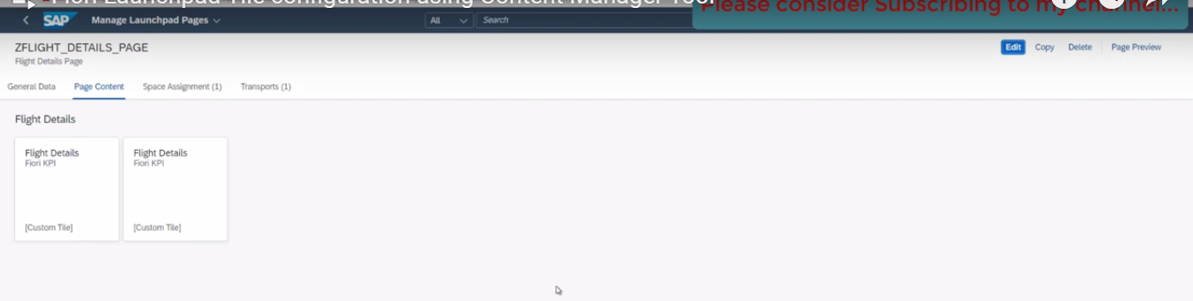

role and everything assigned to this user.--> which we have done our previous videos.

Lets go to our launch pad.

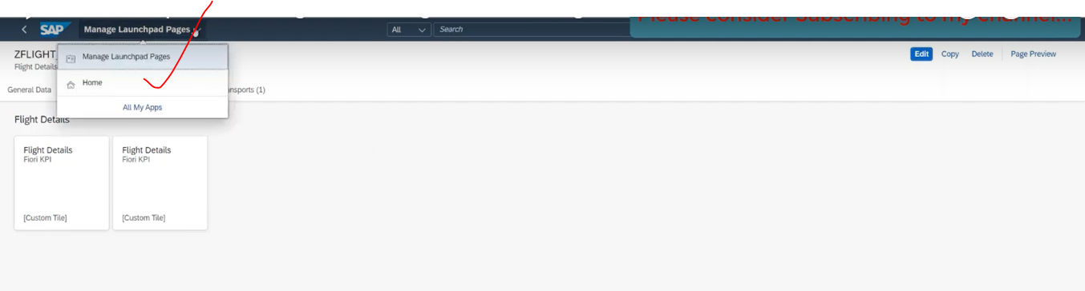

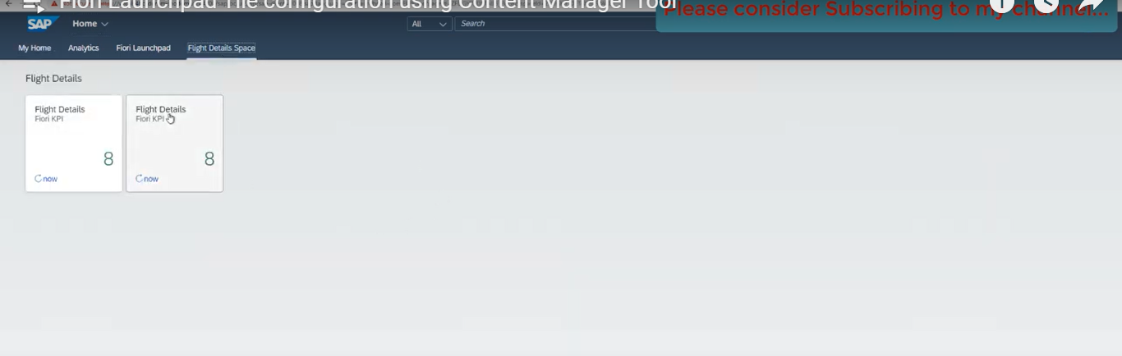

Now we are getting the new tile here.. which we have added through the content manager tool.